Claim History Solution

Exercise 1: Configuration

Claim Pre-update Rule

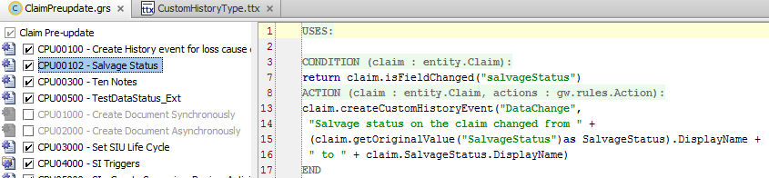

BONUS: PCF Update for History Type Name  
NOTE: The existing “Type” cell is disabled because TypeKeyCell widgets cannot support code in the value property. Instead, a new widget of type “Cell” is created to support dynamic value properties.  
  
Option 1:

